# Task 1

**Description:**Provide the Python code based on the [[fixture_task.py](https://github.com/AntonLazarchik/DQE_LAB_2024_CODE_SAMPLES/blob/main/fixture_task.py)](https://github.com/AntonLazarchik/DQE_LAB_2024_CODE_SAMPLES/blob/main/fixture_task.py) which will contain 2 fixtures. The first fixture is used to track the time of the test execution. The second will track the time of the whole suite execution. All tests must use fixture 1 except the last one. The fixture for the suite time execution must be invoked once.

What is expected to be used in the task: yield in fixtures, fixture scopes, autouse flag, only time module.

**Expected result**: The Python file with implemented code. The screenshot with run results.

fixture_task.py:

import time  
import pytest  
  
  
@pytest.fixture(scope="session", autouse=True)  
def track_suite_time():  
 start = time.time()  
 yield  
 end = time.time()  
 total = end - start  
 print(f"\n Total execution time: {total:.2f} sec")  
  
  
@pytest.fixture  
def track_test_time(request):  
 start = time.time()  
 yield  
 end = time.time()  
 duration = end - start  
 print(f"{request.node.name} exec time: {duration:.2f} sec\n")  
  
  
def add_numbers(a, b):  
 return a + b  
  
  
def test_add_two_positive_numbers(track_test_time):  
 a, b = 3, 5  
 result = add_numbers(a, b)  
 time.sleep(2)  
 assert result == 8  
  
  
def test_add_two_negative_numbers(track_test_time):  
 a, b = -3, -5  
 result = add_numbers(a, b)  
 time.sleep(3)  
 assert result == -8  
  
  
def test_add_negative_and_positive_numbers():  
 a, b = -3, 5  
 result = add_numbers(a, b)  
 time.sleep(10)  
 assert result == 2

Screenshot:

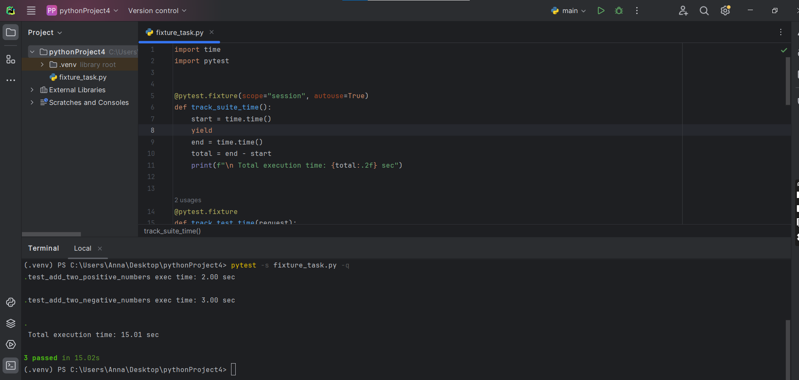

# Task 2

**Description:**

You need to write the logic for the tests and use parametrisation for the test_add_numbers function based on the code [parametrize_task.py](https://github.com/AntonLazarchik/DQE_LAB_2024_CODE_SAMPLES/blob/main/parametrize_task.py). The names of the cases must be also used from the config file [config.yaml](https://github.com/AntonLazarchik/DQE_LAB_2024_CODE_SAMPLES/blob/main/config.yaml).

For test_add_invalid_types you need to verify that the specific exception type is returned. Also, mark the test_add_numbers as smoke and test_add_invalid_types as critical.

Launch tests 3 times using the flags in pytest to run only smoke and second time only critical path tests.

**What is expected to be used in the task:** @pytest.mark, pytest.raises, assert, pytest run commands and flags.

**Expected result:** The Python file with implemented code. The screenshot with 3 run results. First run only for tests marked as smoke. Second run for critical path tests. The third run for the whole suite.

parametrize_task.py:

import pytest  
import yaml  
  
  
def get_numbers_data(config_name):  
 with open(config_name, 'r') as stream:  
 config = yaml.safe_load(stream)  
 return config['cases']  
  
  
def add_numbers(a, b, c):  
 try:  
 return a + b + c  
 except TypeError:  
 raise TypeError('Please check the parameters. All of them must be numeric')  
  
  
test_data = get_numbers_data("config.yaml")  
params = [tuple(case["input"]) + (case["expected"],) for case in test_data]  
ids = [case["case_name"] for case in test_data]  
  
  
@pytest.mark.smoke  
@pytest.mark.parametrize("a, b, c, expected", params, ids=ids)  
def test_add_numbers(a, b, c, expected):  
 result = add_numbers(a, b, c)  
 assert result == expected  
  
  
@pytest.mark.critical  
def test_add_floats():  
 a, b, c = 'a', 2, 1  
 with pytest.raises(TypeError):  
 add_numbers(a, b, c)

Screenshots:  
First run:

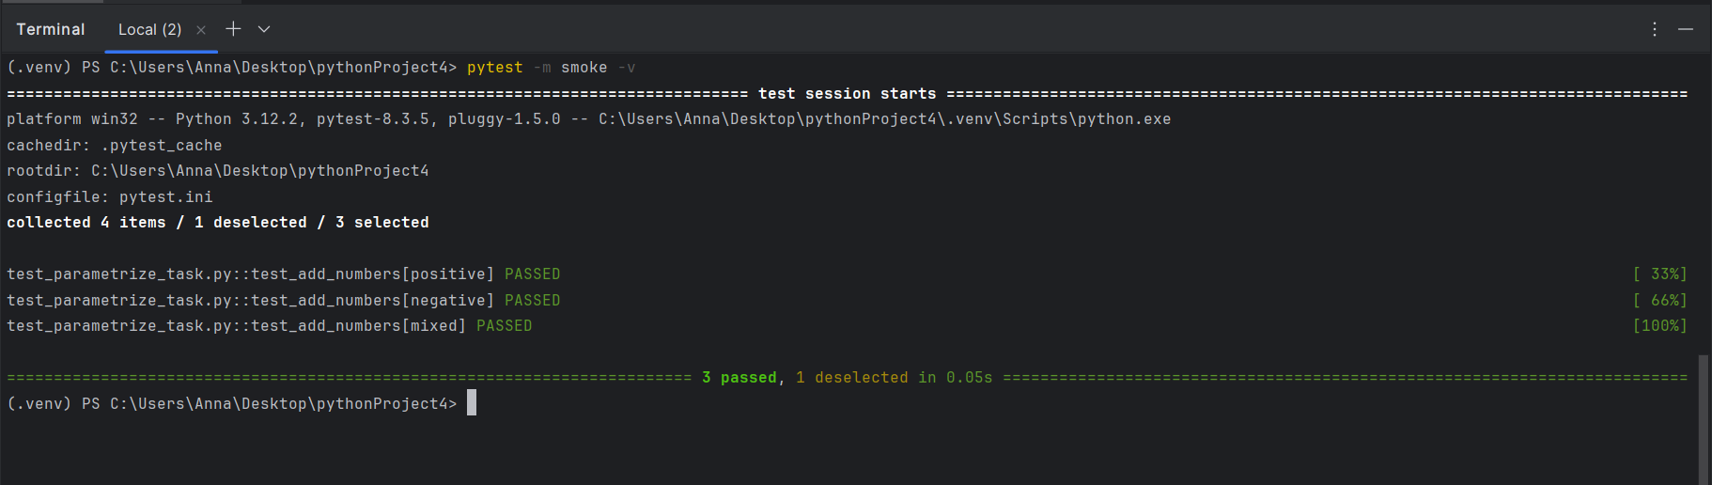

Second run:  
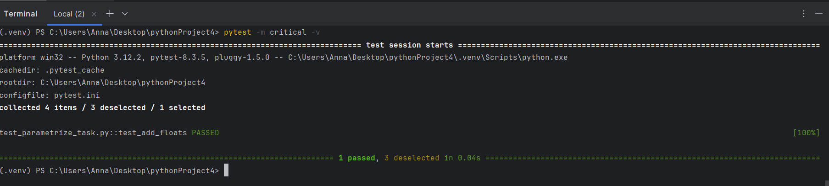

Third run:

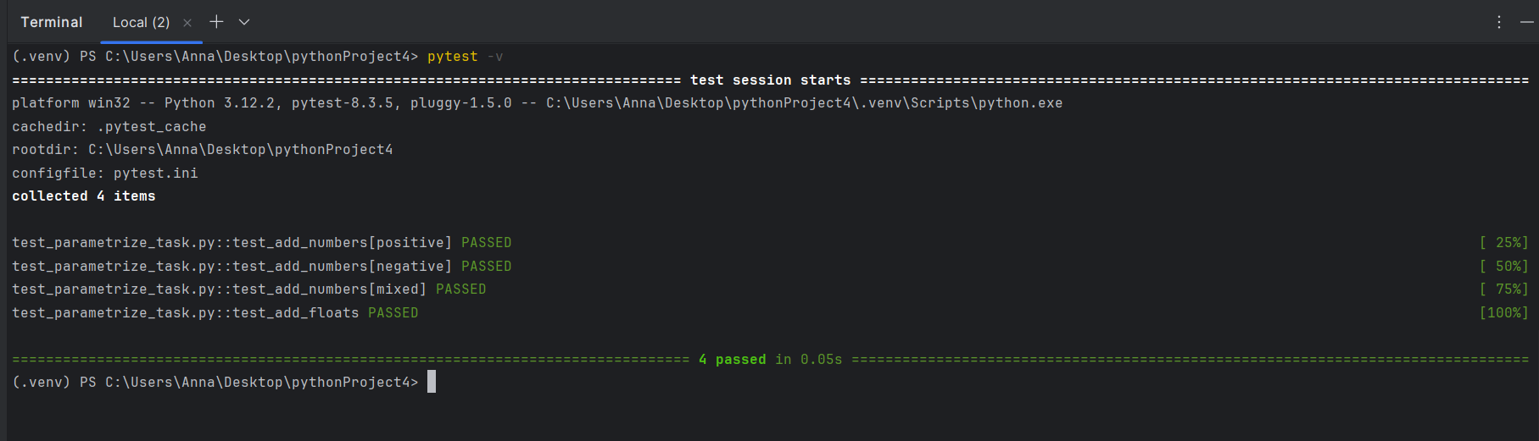

# Task 3

**General Overview:** You need to implement the basic framework to test the tables in your database.

1. 6 tests must be implemented: 3 for smoke tests like the presence of the objects. 3 for the critical path. Any tests can be used for smoke or critical path tests. The main requirement is to have the possibility to run smoke or critical path tests in the same suite or separately.

2. The result of the test run must be provided using the allure. 1 Report for smoke tests. 1 report for critical path. 1 for the whole suite (smoke + critical). Use the ‘–single-file’ flag.

3. Your tests must have custom marks for smoke and critical paths.

4. The SQL queries must be passed through ‘parametrize’ functionality and stored in config files. Config structure example: [config_SQL_example.yaml](https://github.com/AntonLazarchik/DQE_LAB_2024_CODE_SAMPLES/blob/main/config_SQL_example.yaml)

5. The connection to the DB must be implemented and passed to the tests through a fixture. The connection must be closed as a teardown step.

6. conftest.py must be used to store the global configs and fixtures.

7*. Generate the allure report during the test run. (pytest_sessionfinish and subprocess)

The connection to the DB could be established using the pyodbc module for SQL Server or the psycopg2 module for Postgres. The configuration to connect to the DB can be found in the code samples [useful_stuff.py](https://github.com/AntonLazarchik/DQE_LAB_2024_CODE_SAMPLES/blob/main/useful_stuff.py).

**What is expected to be used in the task:** @pytest.mark, assert, allure commands, allure.step, conftest, pytest.ini, pytest run commands and flags.

**Expected result:** The Python files with implemented code. 3 Allure reports (First run only for tests marked as smoke. Second run for critical path tests. The third run for the whole suite)

pytest.ini:

[pytest]  
markers =  
 smoke: mark test as a smoke test  
 critical: mark test as a critical-path test  
  
addopts =  
 --alluredir=reports/allure_raw  
 --clean-alluredir

conftest.py:

import yaml  
import pytest  
import psycopg2  
import subprocess  
  
def pytest_addoption(parser):  
 parser.addoption('--db-host', default='localhost', help='Database host')  
 parser.addoption('--db-port', default='5432', help='Database port')  
 parser.addoption('--db-name', default='test_EPAM', help='Database name')  
 parser.addoption('--db-user', default='postgres', help='Database user')  
 parser.addoption('--db-pass', default='password', help='Database password')  
  
def pytest_generate_tests(metafunc):  
 if 'test_def' not in metafunc.fixturenames:  
 return  
 with open('config_SQL_example.yaml') as f:  
 tests = yaml.safe_load(f)['tests']  
  
 params = []  
 for t in tests:  
 marks = []  
 if t.get('mark') == 'smoke':  
 marks.append(pytest.mark.smoke)  
 elif t.get('mark') == 'critical':  
 marks.append(pytest.mark.critical)  
 params.append(  
 pytest.param(  
 t,  
 id=t['name'],  
 marks=marks  
 )  
 )  
 metafunc.parametrize('test_def', params)  
  
@pytest.fixture(scope='function')  
def db_cursor(request):  
 host = request.config.getoption('--db-host')  
 port = request.config.getoption('--db-port')  
 db = request.config.getoption('--db-name')  
 user = request.config.getoption('--db-user')  
 pwd = request.config.getoption('--db-pass')  
  
 conn = psycopg2.connect(  
 host=host,  
 port=port,  
 database=db,  
 user=user,  
 password=pwd  
 )  
 cur = conn.cursor()  
 yield cur  
 conn.close()  
  
def pytest_sessionfinish(session, exitstatus):marker = session.config.getoption('-m')  
 suite = marker if marker in ('smoke', 'critical') else 'full'  
  
 raw_dir = f'reports/allure_raw_{suite}'  
 out_dir = f'reports/allure_{suite}'  
 cmd = [  
 'allure'  
 'generate',  
 raw_dir,  
 '--clean',  
 '--output', out_dir,  
 '--single-file'  
 ]  
 subprocess.run(cmd, check=True)

config_SQL_example.yaml:

tests:  
 - name: completeness_check_for_users_table  
 sql: >  
 SELECT COUNT(*) FROM INFORMATION_SCHEMA.TABLES  
 WHERE TABLE_SCHEMA = 'public' AND TABLE_NAME = 'users'  
 expected: 1  
 mark: smoke  
  
 - name: row_count_users  
 sql: "SELECT COUNT(*) FROM users"  
 expected: 10  
 mark: critical  
  
 - name: null_email_check  
 sql: "SELECT COUNT(*) FROM users WHERE email IS NULL"  
 expected: 0  
 mark: critical  
  
 - name: completeness_check_orders_table  
 sql: >  
 SELECT COUNT(*) FROM INFORMATION_SCHEMA.TABLES  
 WHERE TABLE_SCHEMA = 'public' AND TABLE_NAME = 'orders'  
 expected: 1  
 mark: smoke  
  
 - name: row_count_orders  
 sql: "SELECT COUNT(*) FROM orders"  
 expected: 100  
 mark: critical  
  
 - name: orphan_orders_check  
 sql: >  
 SELECT COUNT(*) FROM orders o  
 LEFT JOIN users u ON o.user_id = u.id  
 WHERE u.id IS NULL  
 expected: 0  
 mark: smoke

tests/tes_db.py:

import pytest  
import allure  
  
  
def test_sql_queries(db_cursor, test_def, pytestconfig):  
 name = test_def['name']  
 sql = test_def['sql']  
 expected = test_def['expected']  
 mark = test_def.get('mark')  
 marker_filter = pytestconfig.getoption('-m').strip()  
 if marker_filter and mark and mark not in marker_filter.split():  
 pytest.skip(f"Skipping {name}, not in -m {mark}")  
  
 with allure.step(f"Executing: {name}"):  
 db_cursor.execute(sql)  
 result = db_cursor.fetchone()[0]  
 assert result == expected, f"{name}: got {result}, expected {expected}"

First run:

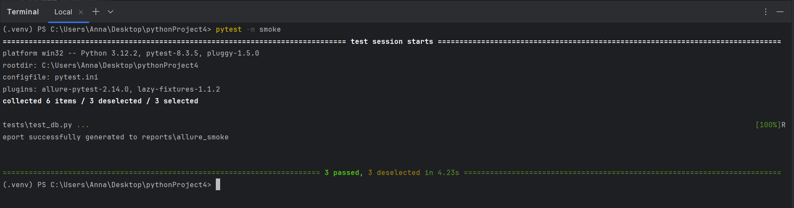

**Second run:**

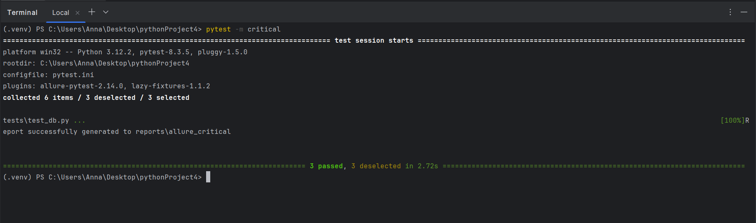

**Third run:**

